Single frequency suppression with elliptic low pass filter

When filtering physiologic signals, low pass filtering is often applied so that the sampling frequency can be reduced and to eliminate line frequency interference. Thus a low pass filter with a stop band frequency of below 60Hz is often applied to the data, permitting resampling of the data at 128Hz (Nyquist frequency 64Hz) and suppressing 60Hz line frequency (and harmonics). If an elliptic or Chebyshev type 2 filter is used, the filter designer can take advantage of the “ripple” in the stop band by “steering” a zero to the line frequency to achieve perfect elimination of the interference. In the US, line frequency is nominally 60Hz, and normally varies in an extremely narrow band of ±0.02Hz.

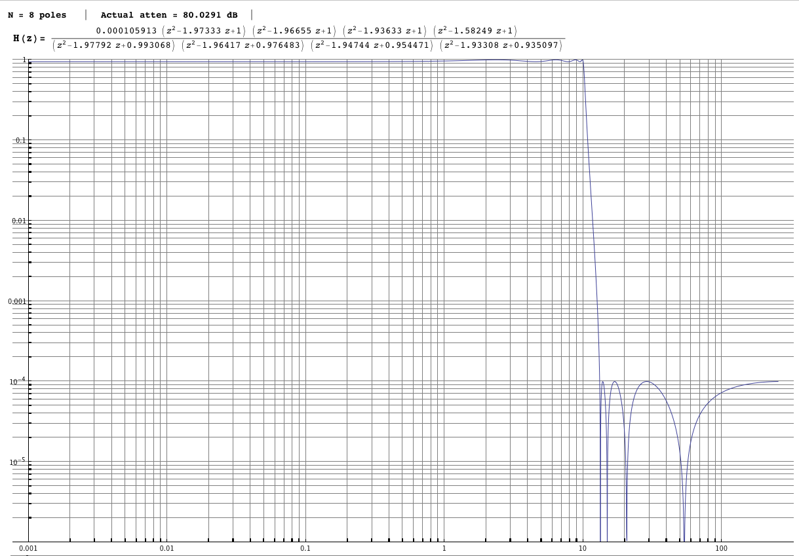

This is a log-log plot of the frequency response of an 8 pole low pass elliptic filter with pass band cutoff of 10Hz, pass band ripple of 5%, and a nominal 80dB attenuation in the stop band which begins around 13.2Hz. Note that there are 4 frequencies in the stop band where the plot sharply descends to zero, off the bottom of the graph. The first of these zeros is extremely narrow, but very close to the stop frequency. Higher order zeros are increasingly far from the stop frequency and progressively wider at any given finite level of attenuation.

Let’s look at a series of filter designs applied to the same signal, sampled at 512s/sec, consisting of a 60.02Hz line interference of 1mV, low frequency “pink” noise with RMS value of 2µV, and embedded “signals” consisting of damped sinewaves with peak amplitudes of 3µV. The result has signal-to-noise ratio of less than ‑60dB. To process this signal we choose to use a high pass filter to remove the noise and a low pass filter to reduce the line frequency ”hum” and permit resampling at 128Hz. We wish to maintain a high pass band cutoff of at least 40Hz.

Here is the original signal, dominated by the line frequency:

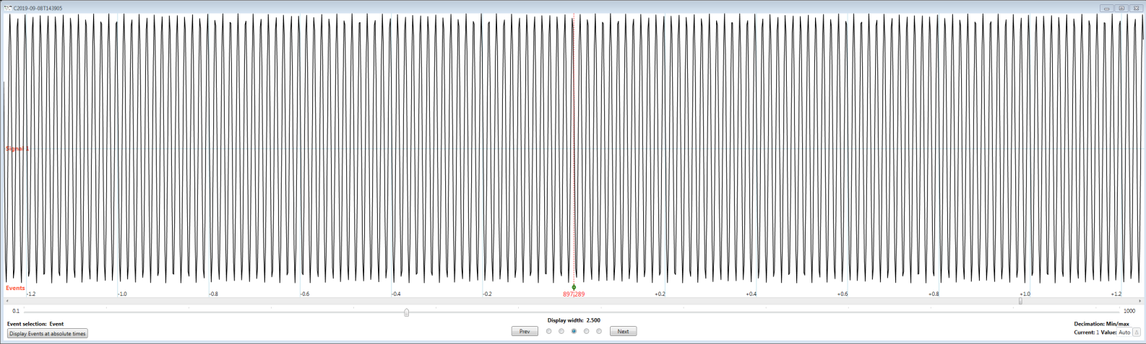

In the following we will be using a causal HP elliptic filter of 5 poles, pass band frequency of 2Hz, band pass ripple of 0.1%, and 40dB stop band suppression, and a causal elliptic LP filter of 7 poles (unless otherwise indicated).

If we design the LP filter with 10% pass band ripple, a cutoff of 42Hz, stop band frequency of 60Hz with 80dB suppression, we get this result, centered on one of the signal events (in all images the signal is amplified to fill the plotting space):

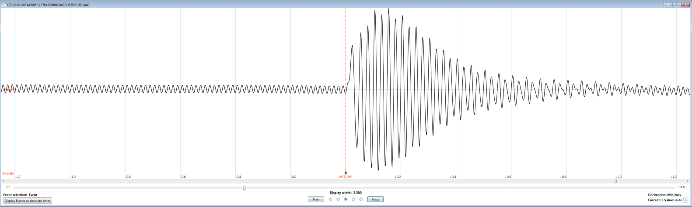

We get what we expect, namely a full 80dB suppression of the line frequency, maybe even a bit more, and a reasonable approximation of the small embedded signal.

Now, let’s design a filter that “steers” the first zero in the stop band to exactly 60Hz. This changes the filter to a cutoff of 41.32Hz and a stop band beginning at 59Hz, but it is still a 7 pole filter 80dB down with 10% ripple. The result:

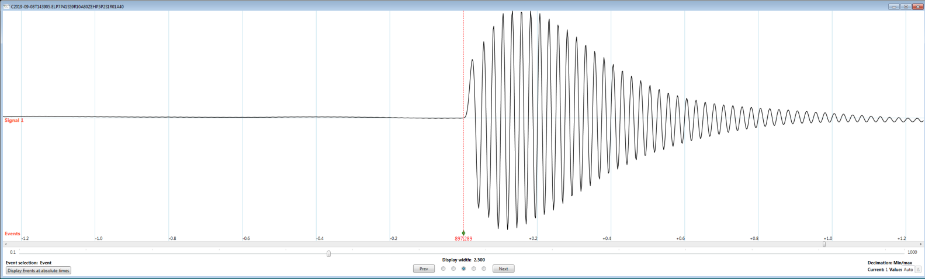

This is quite an improvement, without significantly sacrificing the width of the pass band. Let’s magnify the left hand side of this image:

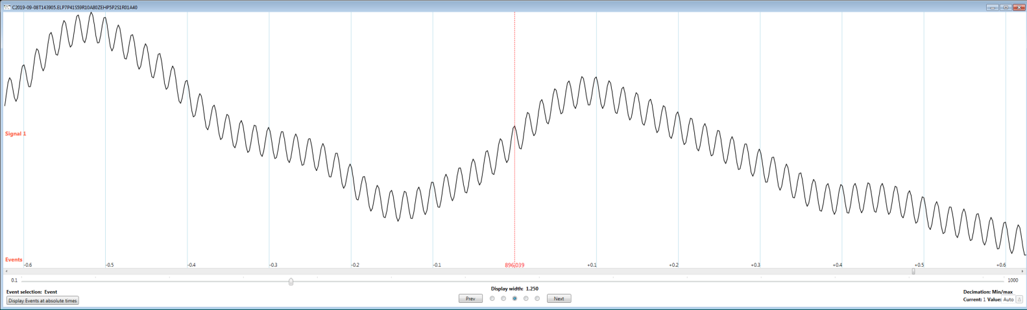

We see that there is some residual line frequency “hum” superimposed on residual low frequency “pink” noise.

But, we can do better. Since our actual line frequency can vary (and, in fact, is not exactly 60Hz in this case), let’s see what happens when we place the second zero in the pass band at 60Hz. Recall that this zero is a bit “wider” or more forgiving for slightly off frequencies. However, in order to maintain our passing bandwidth, we’ll have to increase the number of poles to 8. Here’s the same segment of the result as the last image:

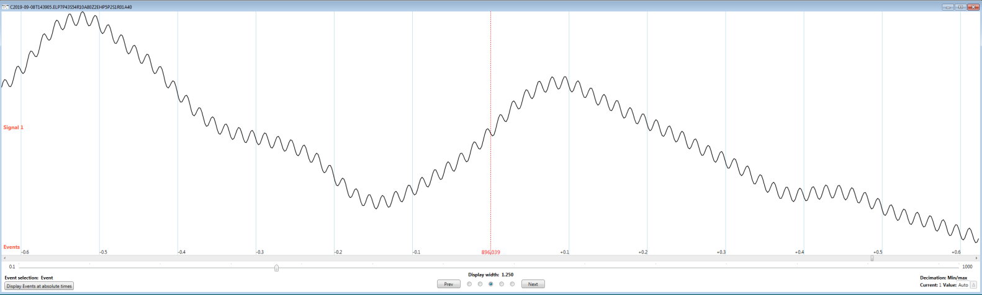

This shows perhaps 6dB improvement in “hum” suppression, but at the cost of an additional pole. Note the improvement is not a direct result of the additional pole (which was needed to maintain pass bandwidth), but is due to the more “forgiving” second pass band zero.

If, in fact, we know precisely what our line frequency is and steer the first zero to it, we get:

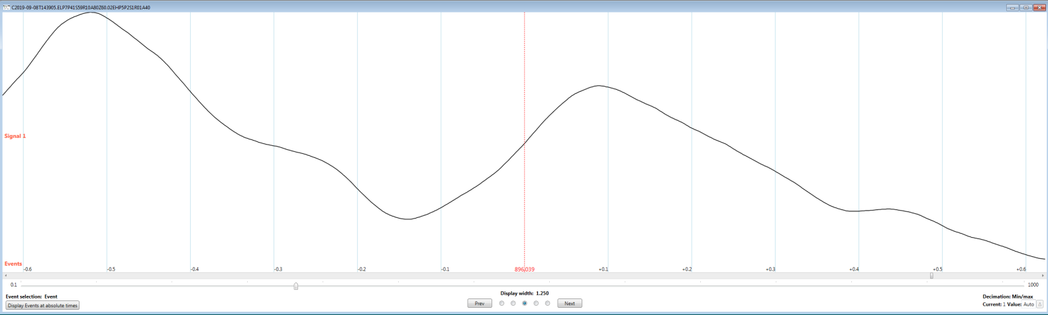

As you can see, it really is a zero! The only residual is the “pink” noise. Here’s an image of the resulting signal-of-interest in this case:

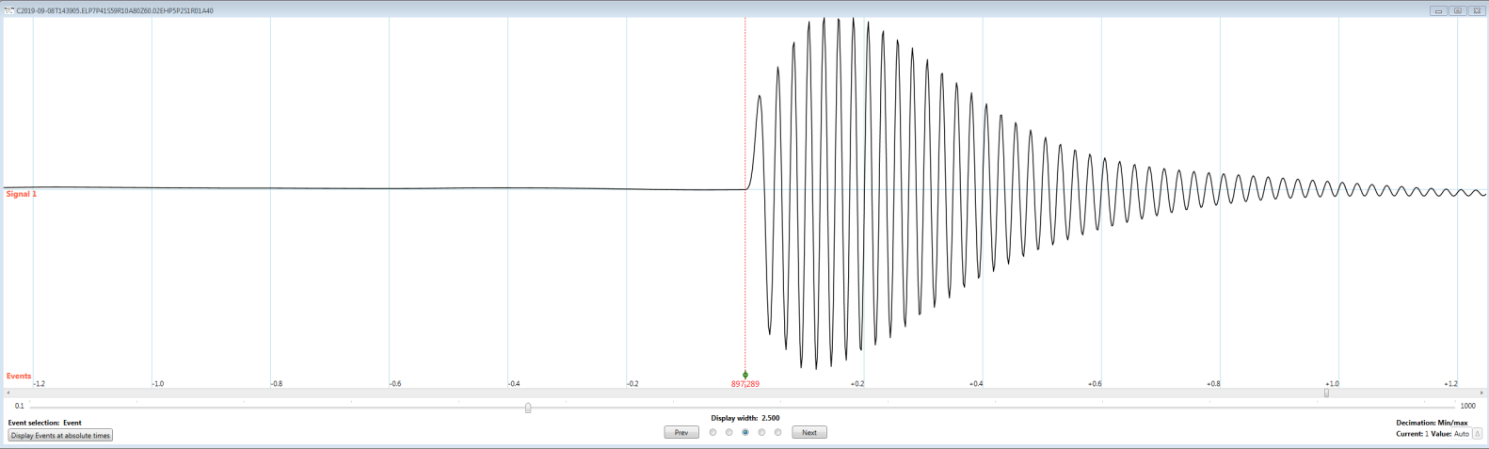

This signal is 3.6µV peak-to-peak with a primary frequency of 40Hz. The original embedded damped sinewave was perhaps 5µV peak-to-peak. The decrease is partially due to the 10% ripple permitted and also due to some “reshaping” of the original signal.

In summary, steering stop band zeros in elliptic (and Chebyshev 2) filters may be a useful tool, particularly when physiologic signals are contaminated by significant line frequency hum. One can improve hum suppression at little cost in bandwidth, need to increase the number of poles, or adding additional “notch” filters. The use of zeros beyond the first might be a useful tool if there is significant variability in line frequency, but at the cost of increasing the number of poles in order to maintain pass bandwidth.